Ocean rates creeping higher ahead of peak season

Zach Strickland, FW Market Expert & Market Analyst, Saturday, May 30, 2026
Original Article: https://www.freightwaves.com/news/ocean-rates-creeping-higher-ahead-of-peak-season
Articles Reproduced by Permission of FreightWaves

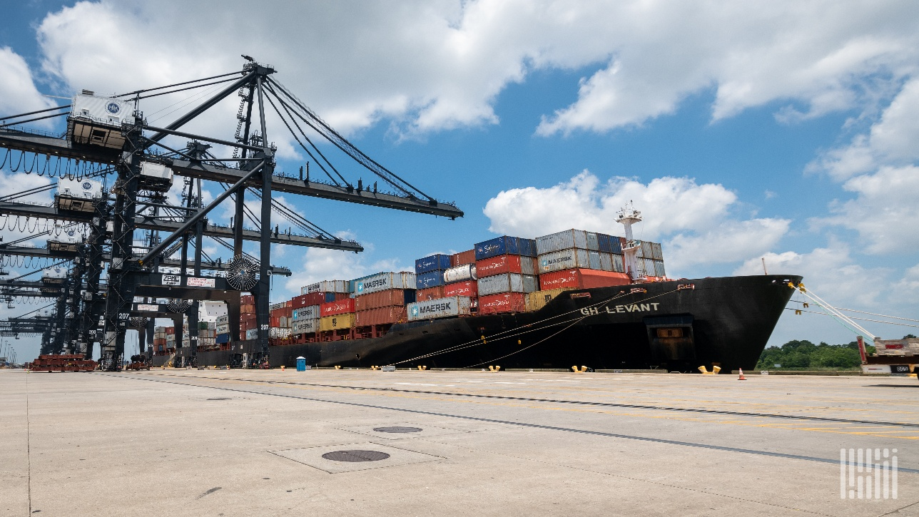
(Photo: FreightWaves)

Maritime container shipping spot rates are up 75% since March

Chart of the Week: Freightos Baltic Daily Index, China to North America West Coast, China to North America East Coast SONAR: FBXD.CNAW, FBXD.CNAE

The ocean container shipping market has not been a major factor in the recent domestic freight market turbulence, but the ongoing conflict in Iran is creating a slow burn in spot rates as we inch closer to peak import season and could become a factor later in the year.

Spot rates for 40-foot equivalent containers moving from China to North America’s East Coast have nearly doubled since late February, rising from $2,600 to over $5,000. The trans-Pacific route has increased nearly $1,400 over the same period to $3,200 as of this past week. Both lanes experienced more than a 75% increase over an eight-week period, according to the Freightos Baltic Daily Index (FBXD).

Maritime shipping disruptions have been a major factor in supply chain management strategies since the pandemic. During the height of the COVID era, importers flooded ports and railheads, congesting and ultimately breaking the infrastructure. This led to a shift in transcontinental freight share from rail to truck.

As recently as 2024, railroads were able to reclaim a large portion of transcontinental volumes as shippers extended their order lead times over concerns that Red Sea attacks were deteriorating service globally.

With overseas transit times a growing concern, shippers pushed order lead times to their highest levels since the end of COVID during the summer of 2024. Ocean transit times averaged approximately five days longer — published schedules plus delays — in July 2024 versus July 2023. Order lead times of 21 days more than doubled during that period, meaning a significant amount of freight had weeks to move domestically. This excess time favored intermodal traffic.

Suez Canal diversions have largely remained in place since early 2024, but lead times have since dropped, though not back to 2023 lows. Inventory management has shifted back toward a more just-in-time approach as warehousing costs are now significantly higher than they were a few years ago.

Tariff uncertainty brought a new level of disruption to the ocean market in 2025, just as supply chains and maritime carriers had adapted to the Houthi attacks. Spot rates were largely lower than in 2024, save for a short-lived spike in June when the most prohibitive tariffs on Chinese goods were eased. This triggered the strongest pull-forward and replenishment event in the post-COVID era, though the market managed it relatively well as rates softened quickly in July.

This latest round of rate increases appears to be largely fuel-cost driven, as capacity remains ample and shippers seem to have adapted to longer transit times, which are now averaging just below the 2024 highs. Demand has also not increased.

Import demand has been flat since early April and has largely trailed 2024 and 2025 levels, with the exception of the post-Liberation Day lull in May 2025. The traditional import peak season runs from late July into August, and there are early signs that demand has begun picking up over the past week.

Ocean rates could face additional upward pressure if demand strengthens in the coming weeks, though that pressure could be offset if the Iran conflict reaches some resolution. Service levels are steady, but transit times remain historically elevated.

Domestic transportation markets have felt little pressure from imports this year, but the risk of that changing is growing — particularly if costs rise or service deteriorates against a backdrop of leaner inventory levels.

